SCHOOL OF COMPUTER SCIENCE AND ARTIFICIAL INTELLIGENCE |  |  |  |  | DEPARTMENT OF COMPUTER SCIENCE ENGINEERING
ProgramName:B. Tech |  |  |  | Assignment Type: Lab |  |  | AcademicYear:2025-2026
CourseCoordinatorName |  |  |  | Venkataramana Veeramsetty
Instructor(s)Name
  Dr. V. Venkataramana (Co-ordinator)
  Dr. T. Sampath Kumar
  Dr. Pramoda Patro
  Dr. Brij Kishor Tiwari
  Dr.J.Ravichander
  Dr. Mohammand Ali Shaik
  Dr. Anirodh Kumar
  Mr. S.Naresh Kumar
  Dr. RAJESH VELPULA
  Mr. Kundhan Kumar
  Ms. Ch.Rajitha
  Mr. M Prakash
  Mr. B.Raju
  Intern 1 (Dharma teja)
  Intern 2 (Sai Prasad)
  Intern 3 (Sowmya)
  NS_2 ( Mounika)
CourseCode |  |  | 24CS002PC215 | CourseTitle |  | AI Assisted Coding
Year/Sem |  |  | II/I | Regulation |  | R24
Date and Day  of Assignment |  |  | Week1 - Tuesday | Time(s)
Duration |  |  | 2 Hours | Applicableto  Batches |  | 24CSBTB01 To 24CSBTB39
AssignmentNumber:1.2(Present assignment number)/24(Total number of assignments)
 | Q.No. | Question |  |  |  |  |  | ExpectedTime  to complete
 | 1 | Lab 1: Environment Setup – GitHub Copilot and VS Code Integration  Lab Objectives:  - To install and configure GitHub Copilot in Visual Studio Code.  - To explore AI-assisted code generation using GitHub Copilot.  - To analyze the accuracy and effectiveness of Copilot's code suggestions.  - To understand prompt-based programming using comments and code context  Lab Outcomes (LOs):  After completing this lab, students will be able to:  - Set up GitHub Copilot in VS Code successfully.  - Use inline comments and context to generate code with Copilot.  - Evaluate AI-generated code for correctness and readability.  - Compare code suggestions based on different prompts and programming styles.  Task Description#1  - Write a comment: # Function to check if a string is a valid palindrome (ignoring spaces and case) and allow Copilot to complete it.  Expected Output#1  - A function that correctly returns True for phrases like "A man a plan a canal Panama"  ANSWER  Prompt:  - Write a python code using function to check if a given string is a valid palindrome.  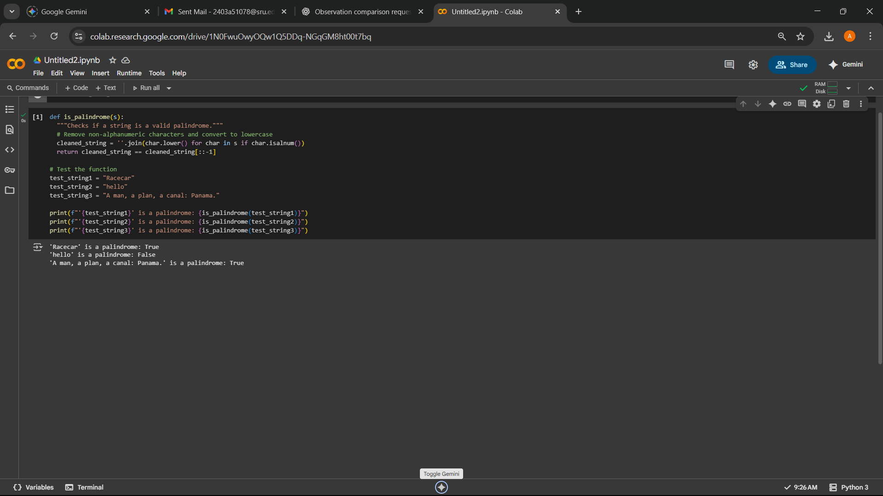  - Write a program to check weather a given string is a palindrome or not by using functios.  Observation:This code defines a function is_palindrome(s) that takes a string s as input. It then preprocesses the string by removing spaces and converting it to lowercase. Finally, it checks if the preprocessed string is equal to its reverse. The example usage shows that the function correctly identifies "Race car" and "A man a plan a canal Panama" as palindromes and "hello" as not a palindrome.  Task Description#2  - Generate a Python function that returns the Fibonacci sequence up to n terms. Prompt with only a function header and docstring  Expected Output#2  - AI completes the function logic using loop or recursion with accurate output  ANSWER  Prompt:  - Generate a program that returns the fibonacci sequence up to n terms using fucntions headers.  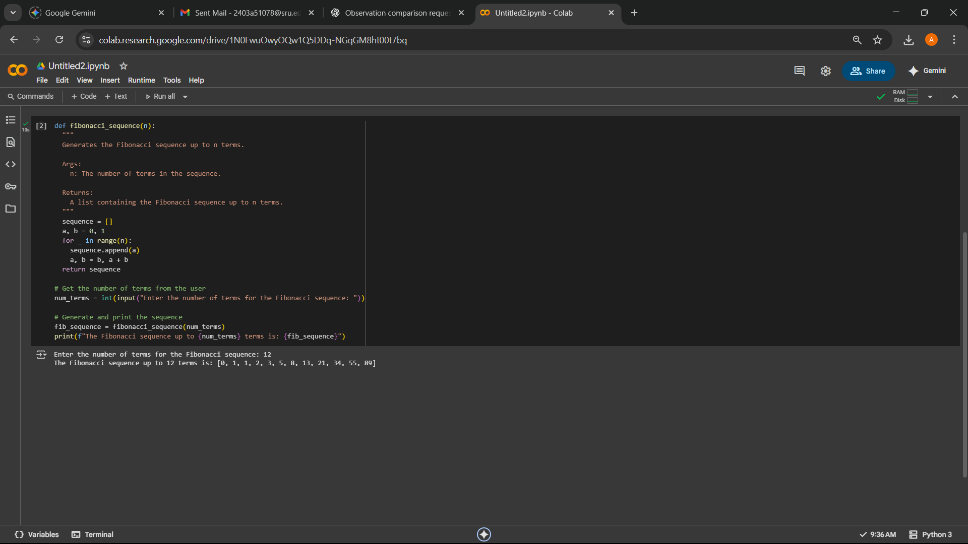  - Write a python code to print fibonacci series up to given number by using function headers and docstring.  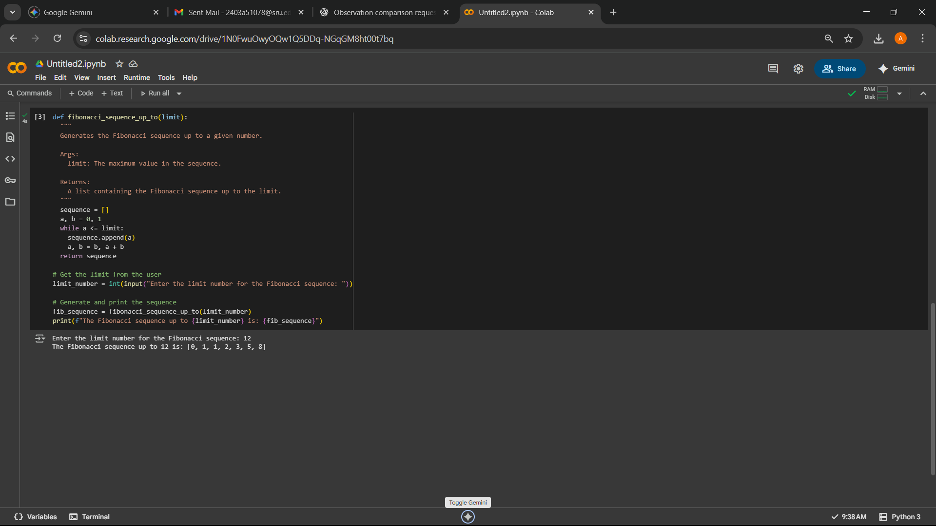  Observation:  This code defines a function called fibonacci_sequence(n) that generates the Fibonacci sequence. It handles edge cases where n is less than or equal to 0 or equal to 1. For n greater than 1, it iteratively calculates the next term by summing the previous two terms and appends it to the sequence until the desired number of terms is reached. The example output shows the function correctly generating the first 10 terms of the Fibonacci sequence: [0, 1, 1, 2, 3, 5, 8, 13, 21, 34].  Task Description#3  - Write a comment like # Function to reverse a string and use Copilot to generate the function.  Expected Output#3  - Auto-completed reverse function  ANSWER  Prompt:  - Write a program that reverse the given string.  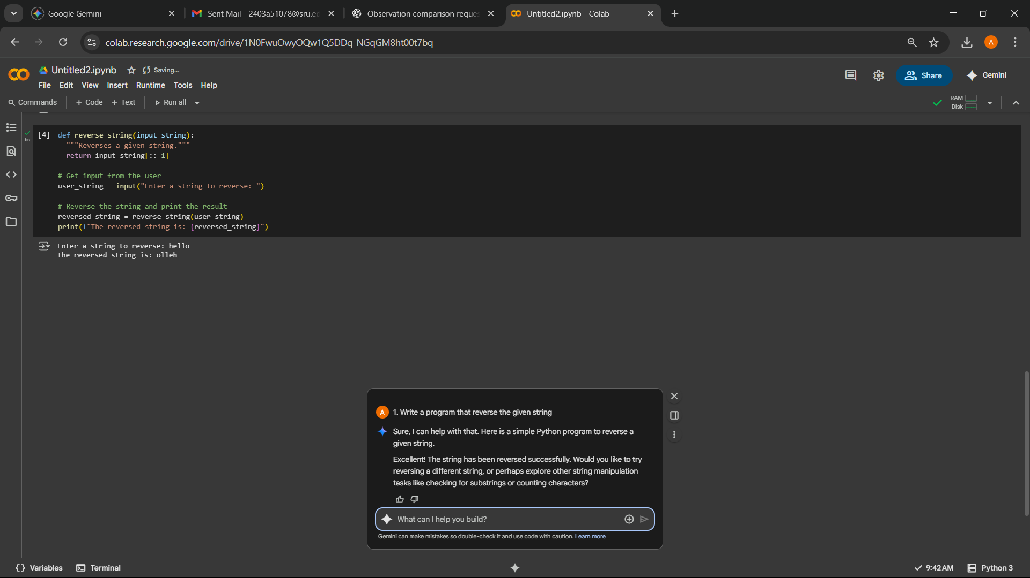  - Generate a python code that reverse a string by using functions.  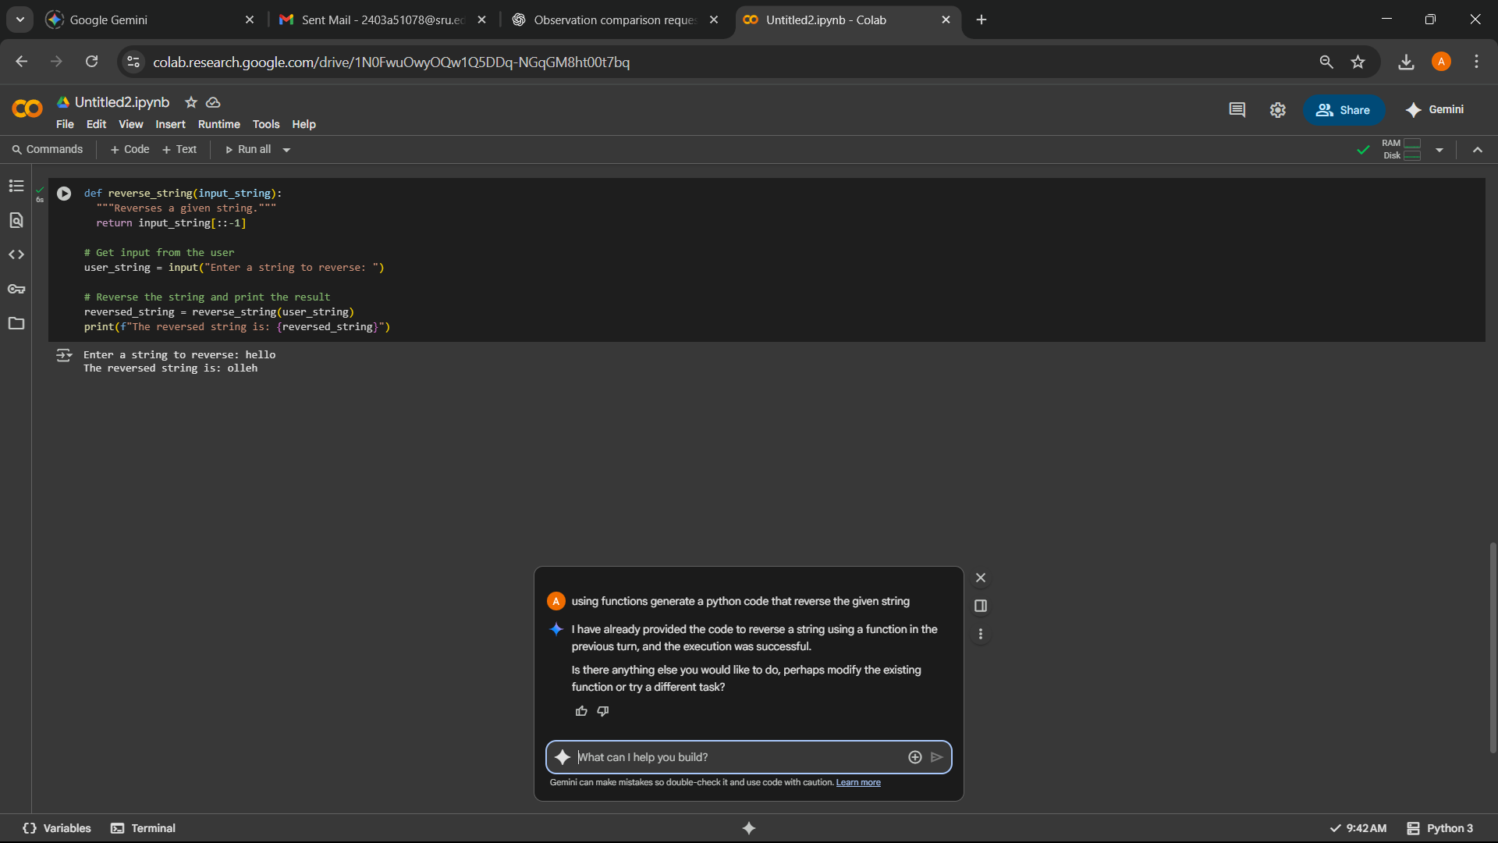  Observation: This code defines a simple function reverse_string(s) that takes a string s as input and returns the reversed string using slicing [::-1]. The example usage shows that the function correctly reverses "hello" to "olleh" and "Python" to "nohtyP". This method is concise and efficient for reversing strings in Python.  Task Description#4  - Generate a program that simulates a basic calculator (add, subtract, multiply, divide). Write the comment: # Simple calculator with 4 operations and let AI complete it.  Expected Output#4  - Fully working calculator with input/output and operator selection logic  ANSWER  Prompt:  - Write a python code that simulates a basic calculations  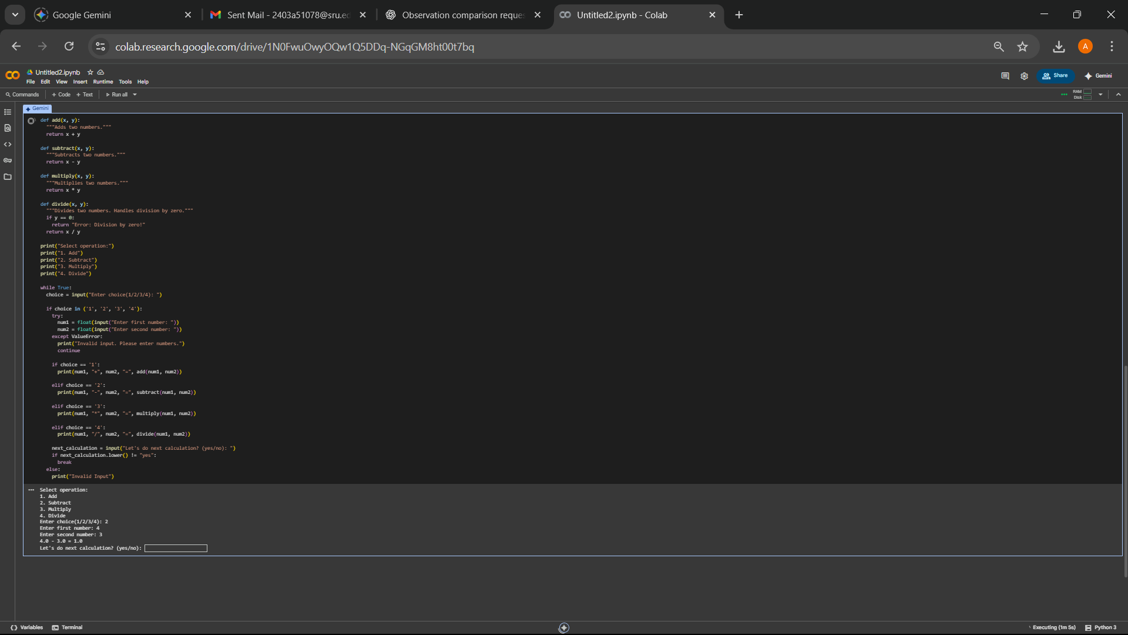  - Generate a program that can do all the basic calculations of caculator.  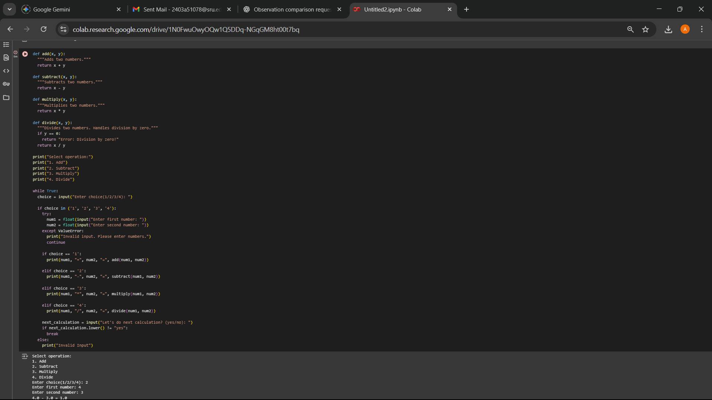  Observation: This code implements a simple command-line calculator with four basic operations: addition, subtraction, multiplication, and division. It prompts the user to select an operation and then enter two numbers. It includes error handling for non-numeric input and division by zero. The example output shows the program successfully performing an addition operation.  Task Description#5  - Use a comment to instruct AI to write a function that reads a file and returns the number of lines..  Expected Output#5  - Functional implementation using open() or with open() and readlines()  ANSWER  Prompt:  - Write a python code that performs file handling by creatring a file then read and display the content.  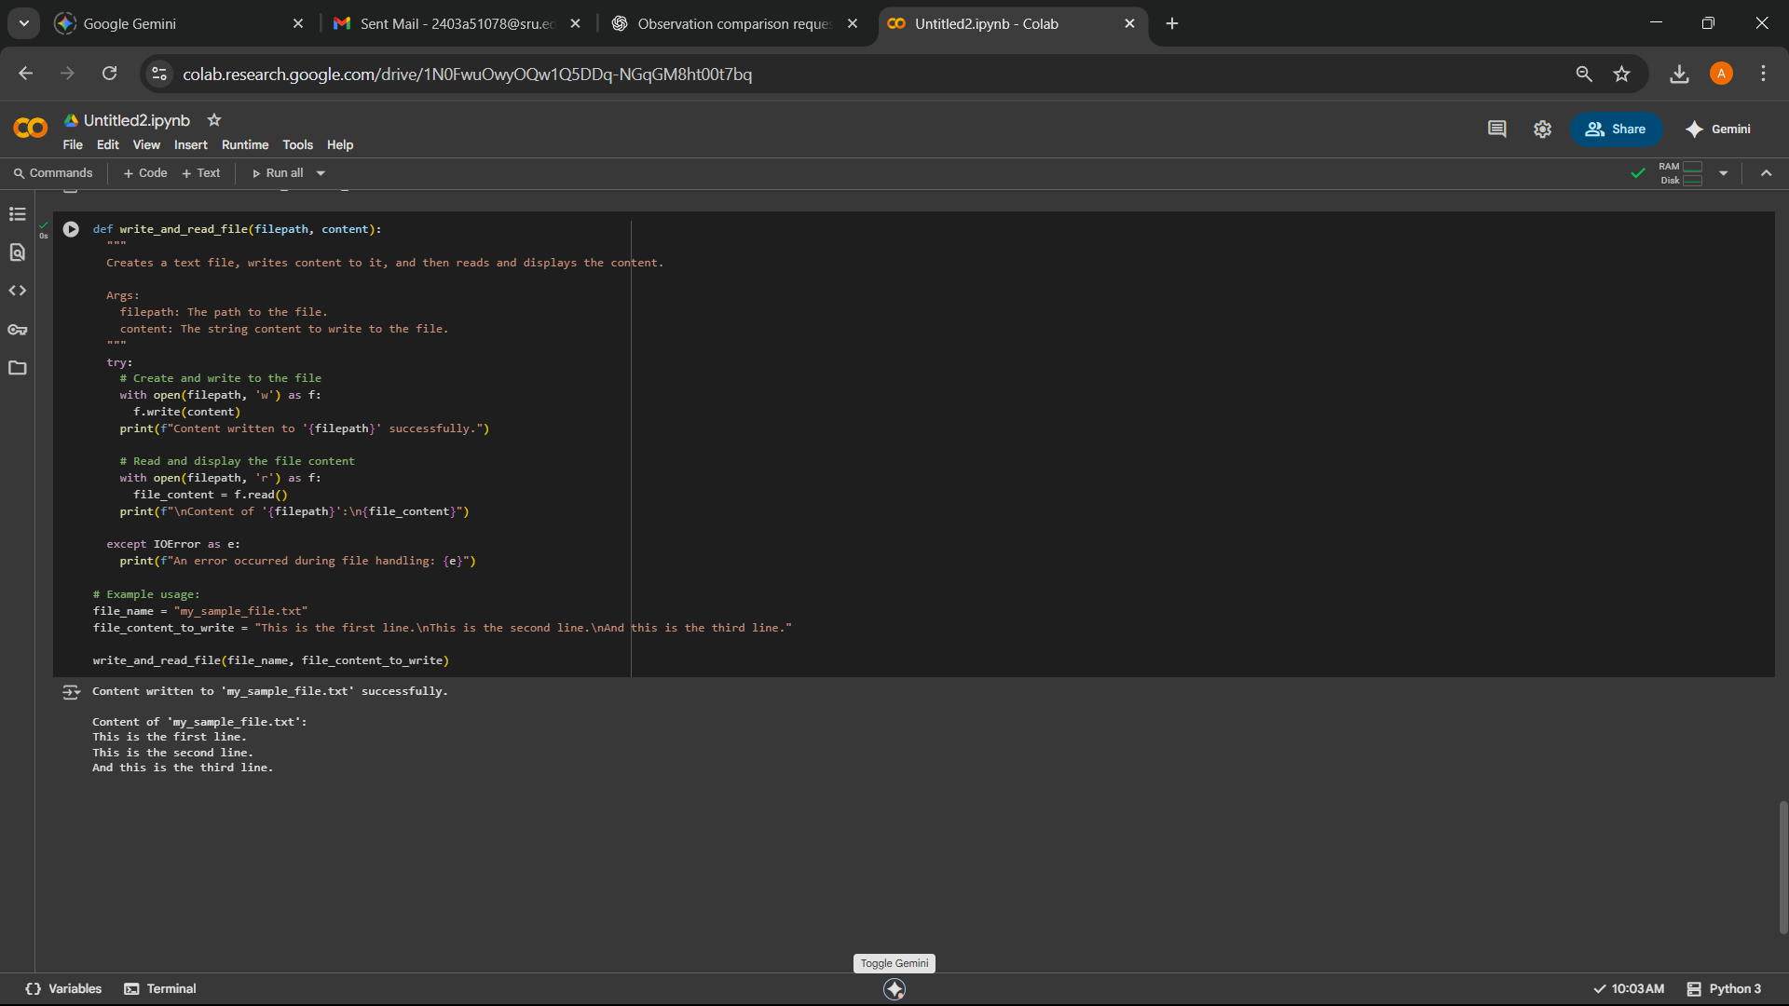  Observation: This code demonstrates basic file handling operations in Python. It creates a text file named my_example_file.txt, writes some predefined content into it using the open() function in write mode ('w'), and then reads the content back from the same file using the open() function in read mode ('r'). The with open(...) syntax is used to ensure the file is properly closed even if errors occur. The code also includes basic error handling for IOError and other exceptions. The output confirms that the file was created and written successfully and then displays the content that was read from the file.  Note: Report should be submitted a word document for all tasks in a single document with prompts, comments & code explanation, and output and if required, screenshots  Evaluation Criteria: |  |  |  |  |  | Week1 - wednesday
  Criteria | Max Marks
  Task #1 | 0.5
  Task #2 | 0.5
  Task #3 | 0.5
  Task #4 | 0.5
  Task #5 | 0.5
  Total | 2.5 Marks

